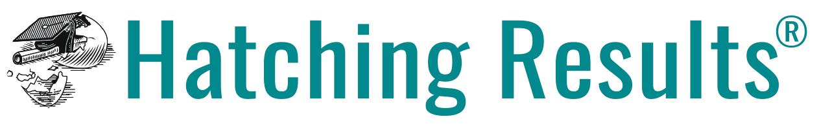 | *Sample*  School Counselor Job Description | Please feel free to use this language when revising your district’s job description

Reports to: [Set locally]
Evaluated by: [Set locally]

Job Summary: As vital members of the school’s educational leadership team, school counselors maximize the success of ALL students by planning, implementing, evaluating, and improving the school’s comprehensive school counseling program. They use a multi-tiered, multi-domain system of supports to promote students’ academic, college/career, and social/emotional development, spending the majority of their time in direct service with students or communicating with others on behalf of students. School counselors lead, advocate, and collaborate to effect positive systemic change that promotes equity and access for all students.

Essential Functions:

- Implement a school counseling program that is aligned to the American School Counselor Association (ASCA) National Model, schoolwide goals and improvement metrics, districtwide priorities, and current, evidence-based practices and systems that have been shown to promote student success
- Abide by the ASCA Ethical Standards for School Counseling and the ASCA School Counselor Professional Standards and Competencies to guide professional growth and development
- Conduct regular reviews of school and student data to inform student outcomes through program SMART goals, tiered supports, closing the gap activities, interventions, equity initiatives, and advocacy efforts.
- Evaluate and share the results of the school counseling program’s impact and effectiveness with key stakeholders. Provide recommendations for improving the school counseling program. Seek feedback regularly from the school counseling program Advisory Council.
- Spend their time in alignment with ASCA’s recommendation that 80% or more of the school counselor’s time is spent providing direct student services (instruction, appraisal, advisement, and counseling with students) and indirect student services (collaboration, consultation, and referrals with families, teachers, administrators, school staff, and community stakeholders).
- Implement comprehensive Tier 1 school counseling supports that reach ALL students, including the teaching of developmentally appropriate, culturally responsive lessons and schoolwide programs and activities designed to shift student attitudes, knowledge, and skills. At the middle and high school levels, school counselors develop systems to ensure that all students complete and annually update their Individual Learning Plans (ILPs)/graduation plans/postsecondary plans.
- Provide intentional, targeted, culturally responsive Tier 2 school counseling interventions for students identified as deserving of additional support (via predetermined data metrics and/or referrals).
- Provide intensified Tier 3 school counseling supports/referrals for students experiencing emergency or crisis situations, as well as those whose needs remain unmet after receiving Tier 2 supports. Provide referrals to resources to support students in need of long term therapy or treatment of a mental, emotional, or bodily disorder.
- Consult, collaborate, and team with key stakeholders to support student success (i.e. referral of students/families to district and community resources; sharing evidence-based support strategies with families and staff; serving as a student advocate; providing family education; teaming with other student services personnel; reaching out to other experts and stakeholders to obtain information on students’ needs; teaming/partnering/serving on committees and advisory boards; creating formalized partnerships with community based organizations).
- Promote equity and access for all students and make a significant impact in creating a school culture free from racism and bias in all forms.
- Engage in high-quality school counseling system support, including, but not limited to the development of action plans, lesson plans, annual planning calendars, annual administrator conferences, needs assessments, results reports, data-sharing presentations, a school counseling program advisory council, progress monitoring of school counseling interventions and activities, planning time for the creation and improvement of data-driven school counseling interventions, regular meetings with other school counselors, etc.
- Utilize technology and other virtual tools to support efficient and effective program delivery and communication with the school community.
- Actively pursue and participate in professional development, so as to stay current with evidence-based practices in the field. Examples: Maintaining membership in state and national professional organizations (i.e. American School Counselor Association), reading professional journals, attending local, state, and national workshops and conferences, engaging in continuing education coursework as appropriate.

Qualifications/Skills:

- Master’s degree or higher in school counseling
- A current state license/certification/endorsement in school counseling
- Commitment to uphold local, state, and national standards in school counseling
- High physical and emotional energy, problem-solving mindset, and a supreme ability to handle stress

